PRODUCT CASE STUDY · VERSION 2
Stillwater
From a scripted demo to a companion that genuinely understands you
How a generic screen-and-timer starter became a calm movement companion, and how a declined take-home turned into a second version that does what the brief actually asked: understand people in their own words, keep them safe, and prove it.

Role: product thinking, business analysis, interaction design and implementation (AI-assisted engineering)
Format: local, runnable web prototype. TypeScript, declarative screens, optional Claude understanding layer
Context: built on a starter harness provided for a take-home product exercise; version 2 written after that submission was declined

What changed in version 2, in five lines
It now understands people. Claude reads what you type: “been hunched over a laptop since 8”, “my knee’s being weird”, “my wrists are tired”.
It is safer, not riskier. A keyword safety floor always runs; Claude can add caution but never remove it. Safety wording is never generated.
It gets you moving faster. Two questions instead of six screens.
It gives you a reason to return. One word for something you actually did, kept on a shelf if you opt in.
It is measured. On 44 realistic messages: keyword rules alone missed 10 of 16 body concerns; version 2 missed none.

1. Executive summary
The brief was open-ended: build an AI-guided, fictional workout experience on a provided starter, keep it runnable locally, use simulated actions, and report which runtime modes were tested.
Version 1 became Stillwater over nine focused iterations: an honest, calm, well-tested companion with a beautiful workout stage. But all of its “understanding” was hand-written keyword rules, and the AI instructions had never been run against a model. The submission was declined.
Version 2 started with a gap review instead of a guess. The headline gap was clear: the brief asked for AI guidance, and I had shown none running. Version 2 adds a real understanding layer while keeping everything that made version 1 trustworthy. Claude reads the person’s words; the app’s own tested code still draws every screen, sets every duration and writes every safety message.
North star (unchanged). The person should finish thinking “that felt good, and I would do it again”, because the time was pleasant and respected, not because of streaks or pressure.

At a glance
 | Version 1 (submitted) | Version 2 (now)
Understanding | Keyword rules in 14 categories | Claude reads free text, with keyword rules as a safety floor and offline fallback
Safety | Word list (“pain”, “hurt”, “dizzy”) | Claude plus word list; the more cautious reading wins. 0 of 16 realistic concerns missed
Getting started | Six screens before choosing a session | Two questions: an optional name, then what today needs
Mid-session | Swap between preset levels | Also: a small, specific tip for the current movement
Reason to return | Random fitness word at the start | A word from the session you just did, kept on an opt-in shelf
Runtime modes tested | Mock only | Mock, and Claude live (Pro plan route), with an evaluation and a recorded walkthrough
Quality | 73 unit/HTTP tests, 27 browser journeys | 83 unit/HTTP tests, 28 browser journeys, 44-message live eval

2. The brief and its constraints
The exercise was intentionally open: decide the interaction, guidance and presentation yourself, keep it local, and return source plus an honest note about which runtime modes were tested.
- Declarative screens only. Screens are data, validated against a component catalogue and rendered by trusted local code. No generated code.
- No paid services by default. Everything must work offline in a scripted Mock mode. Live model use needs explicit setup and consent.
- Honesty about capability. No camera, voice or sensing exists, so the product cannot imply them. Timers measure time on a page, not movement.
- No medical advice. Movement guidance stays general, gentle and optional.
These constraints shaped version 2’s biggest decision: if the AI is allowed in, it must work inside them, not around them.

3. Why there is a version 2

The decline, treated as a requirements problem
The rejection email said only that they had decided not to move forward. With no feedback to work from, I did what I would do on a project with an unhappy stakeholder: went back to the original requirement, compared it line by line with what was delivered, and ranked the gaps by how much they mattered to the person evaluating it.
What the reviewer would look for | What version 1 showed | Severity
AI guiding the experience | A scripted app; AI instructions never run | High
Runtime modes tested | “Mock only” | High
Safe handling of everyday phrasing about the body | Missed “that pinched”, “knee feels weird”, “nearly blacked out” | High
A quick, guided start | Six screens of setup before any movement | Medium
Adapting to the person | Preset swaps only | Medium
Evidence and a clear write-up | No measure of understanding; long README | Medium

The lesson in one line: I polished everything around the core ask and under-delivered the core ask itself. Version 1 had strong product instincts (honesty, safety, calm) but showed none of the skill the brief was testing. The full gap analysis and requirement-by-requirement change log are in the BRD.

4. Product principles
The six version 1 principles still hold. Version 2 adds two that govern the AI.
- The interface is the product. Conversation supports the workout; it never replaces it.
- Intent decides. Today’s stated need picks the session.
- Honest by construction. Durations come from the timers. Nothing claims a body was observed.
- Safety overrides progression. Pain pauses, holds and asks; it never substitutes another exercise.
- Present at the edges, quiet in the middle. The companion speaks at arrival, choices, first and last movement, and the close.
- Return because it felt good. No streaks, guilt or notifications.
- New: Claude understands; trusted code draws. The model interprets words. It never writes screens, durations or safety text.
- New: AI can only make it safer. A fixed safety floor always runs, and the more cautious reading wins.

5. Version 2: what changed and why
Each change is told the way I would present it in a product review: the problem, the options, the decision, and the evidence.

5.1 A real understanding layer
The problem. People describe how they feel loosely. Keyword rules handled the phrases I had anticipated and broke on everything else. “Feel like a rusty hinge” or “too much coffee, I’m buzzing” got a follow-up question instead of a suggestion.
Options considered. (a) Add more keywords. Cheap, but endless and brittle. (b) Let an AI generate whole screens, which is what the starter’s adapters did. Flexible, but it could invent a ten-minute session, give medical advice, or produce a broken screen. (c) Let the AI interpret only, and keep the existing tested code drawing everything.
Decision. Option (c). Claude reads the message and returns a short, fixed-format answer: the safety level, the closest session and intensity, what it heard, any mid-session request, and one friendly sentence. The app checks that answer and builds the screen exactly as before. Claude cannot invent a duration: the app appends the real one, for example “(2:40)”.
Evidence. 44 of 44 realistic messages read correctly in the live evaluation, against 13 of 44 for version 1’s keyword rules. Button taps and commands never go to the model, so they stay instant.
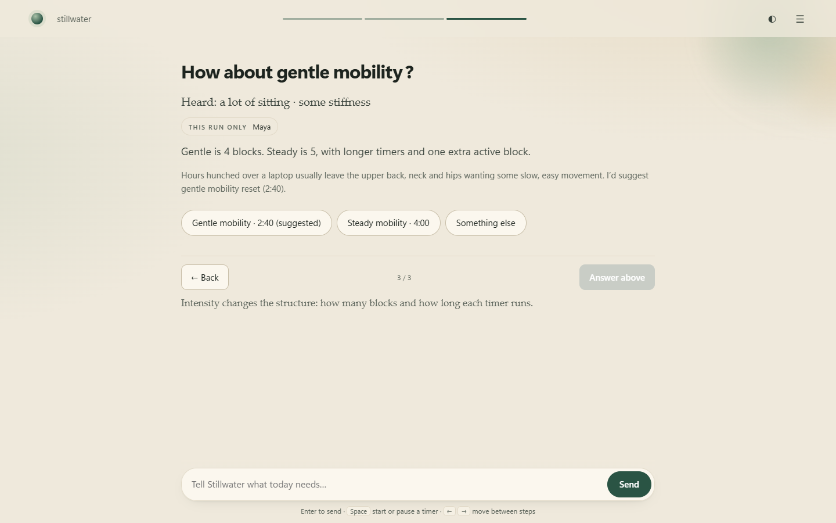
Claude read “been hunched over my laptop since 8am”. The app built the screen: what was heard, a suggestion and its true length.

5.2 A safety floor that AI can only raise
The problem. Adding AI to a fitness product creates a new risk: a model that talks someone out of stopping. At the same time, the old word list missed casual phrasing like “ooh that pinched” or “left arm’s gone tingly and weak”.
Options considered. Trust the model alone; keep keywords alone; or run both with a clear rule for disagreements.
Decision. Run both. If either one detects a body concern, the session stops, and the more serious level wins. Claude can raise a concern the list missed but can never lower one the list found. The words people see in a safety moment are always Stillwater’s fixed, reviewed wording, never generated text. If Claude is unreachable, the list answers and the reply says so.
Evidence. 0 of 16 body concerns missed and 0 false alarms in the live evaluation. Automated tests use a fake model that says “just push through it” and check that this text never reaches the screen.
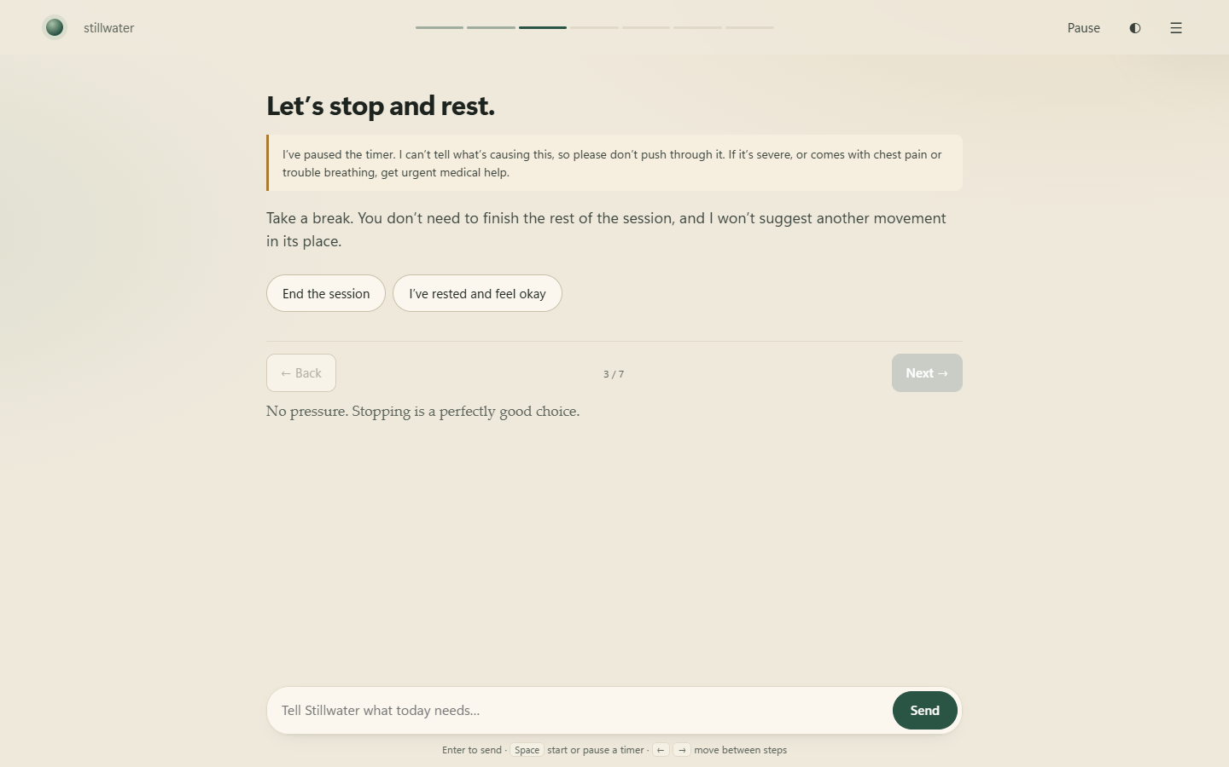
“Ooh that pinched”, missed by keyword rules and caught by Claude. The timer pauses and the choice belongs to the person.

5.3 Tips for the movement you are on
The problem. Version 1 could swap a whole session but could not answer “my wrists are tired” or “I’m on a train, can I sit?”.
Options considered. Write a tip for every movement and every complaint (impossible to cover), or let Claude suggest one small adjustment.
Decision. Claude may suggest one gentle change to the current movement, using only what that movement already involves. It appears as an offer with “Keep going” or “End the session”. If the issue is pain, it is treated as safety, never as a tip.
Evidence. For tired wrists on a cat-cow movement, Claude suggested coming onto the forearms or switching to the seated spine waves that the movement’s own description offers. It was grounded in the content, not invented.
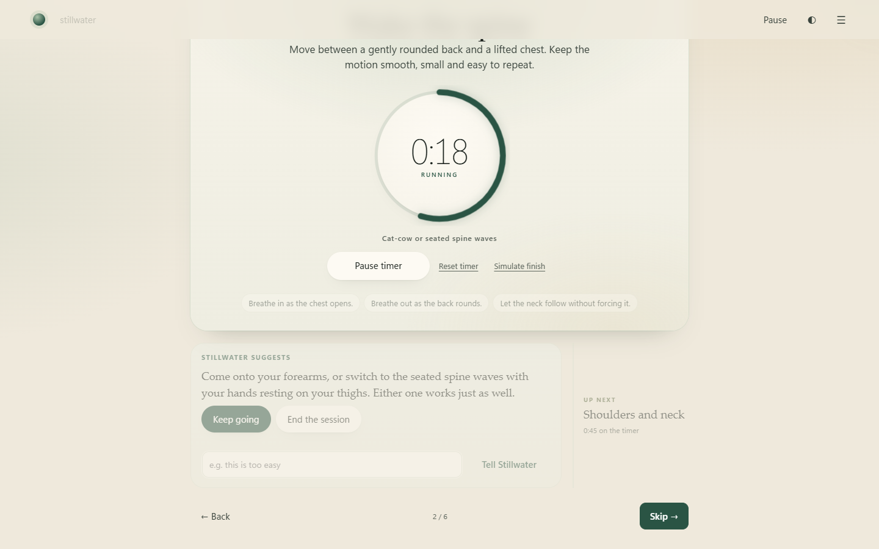
A tip for this exact movement, offered rather than forced.

5.4 Two questions, then movement
The problem. Version 1 asked for a greeting, a fitness word, a name, a training style and a mood, then an intensity: six screens before any movement. The training style only changed the tone of voice, which few people would notice.
Options considered. Keep everything but make it faster; make some steps optional; or cut to what actually changes the session.
Decision. Cut to two questions: an optional first name, then what today needs. The style question was removed; its value did not justify a screen. The fitness word moved to the end (5.5).
Evidence. From “Start” to choosing a session in two answers. Browser tests check that Next still cannot skip an unanswered question.
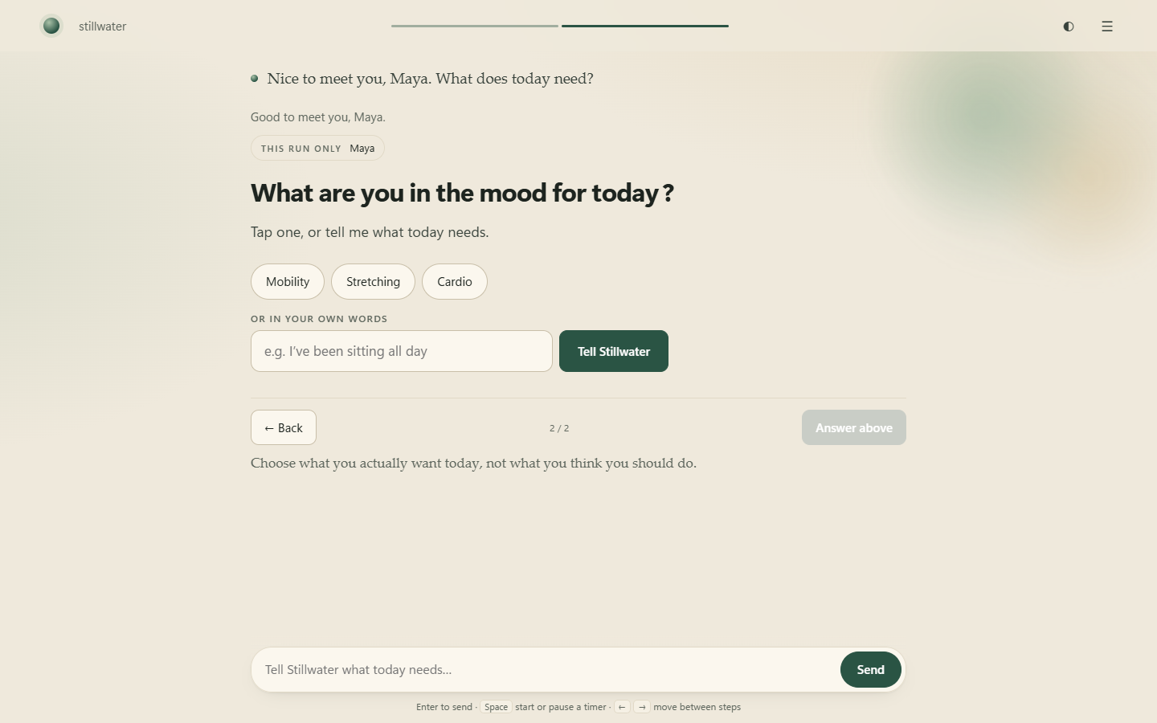
The second and last question: tap a choice, or say it in your own words.

5.5 A word that means something, and a reason to return
The problem. At the front door, a random fitness word was trivia that delayed the workout, and nothing connected it to a reason to come back.
Options considered. Remove it; keep it but make it skippable; or move it to where it has meaning.
Decision. Show it at the end, naming something the person just did: “Hip hinge. You met this in ‘Hip hinge reach’.” Each session rotates through two or three words, so repeat sessions teach something new. With Remember me switched on, words collect on the home screen.
Evidence. Tests check that every session’s word links to a real movement in that session, including after a mid-session switch. That case was a real bug, found while recording the walkthrough and fixed.
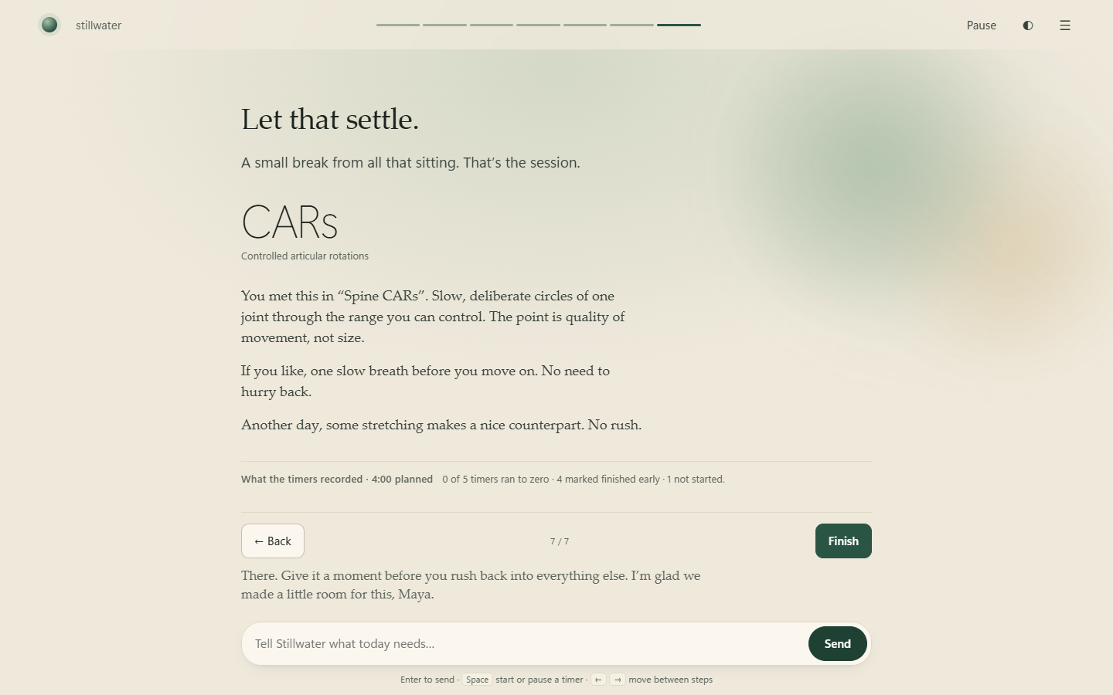
A calm close, then one word from the session itself.
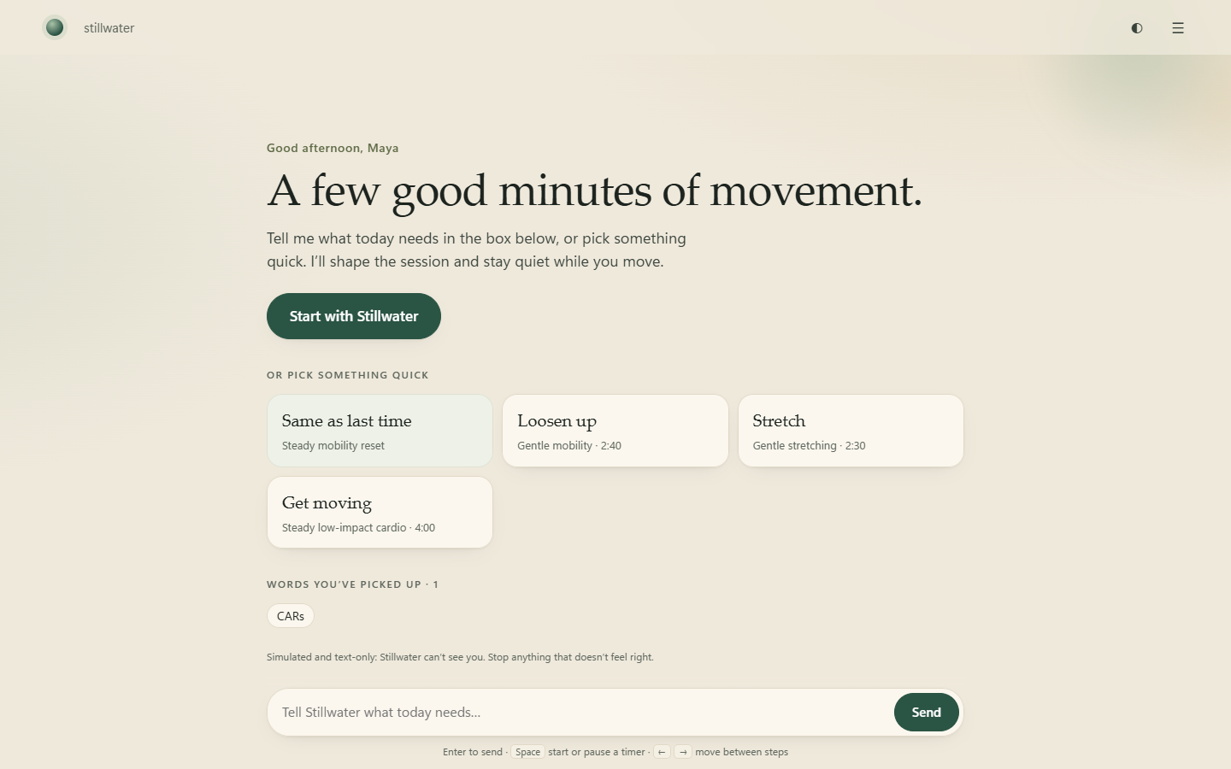
With Remember me on, words collect on home: a small, pressure-free reason to come back.

5.6 Measuring understanding
Version 1 had good tests for the app, but nothing measured whether it understood people. Version 2 adds a fixed set of 44 realistic messages: 16 body concerns, 4 figures of speech, 15 everyday needs and 15 mid-session requests. Both approaches are scored on the same set.
 | Overall | Body concerns missed | False alarms
Keyword rules alone (version 1’s approach) | 13 / 44 | 10 of 16 | 1
Claude + keyword floor (version 2) | 44 / 44 | 0 of 16 | 0

What the first live run caught. It scored 42 of 44, and both misses taught something. “Pain in the neck kind of day at work” was flagged by the keyword floor, not by Claude, so the floor now ignores pain idioms (a test proves “my neck pain is bad” is still caught). “Easy peasy” was read as a comment, not a request, so Claude’s instructions now say that counts as an offer to go harder.
Honest caveat. I wrote these messages alongside Claude’s instructions, so 44 of 44 shows the design works, not that it generalises. A held-out set written by other people is the first thing on the next-steps list.

5.7 Running it without an API key
I did not have API credit, but I did have a Claude Pro plan. Version 2 can therefore read messages through the official Claude command-line tool using the person’s own login, in a locked-down way: no tools (it cannot read files or run commands), no settings, no saved session, an empty temporary folder, and the message passed as data rather than as a command. An API key works too and is faster. Mock remains the default, needs nothing, and sends nothing anywhere.

5.8 What happens when someone types, step by step
- The browser sends the message and the current screen to the local app.
- The app decides whether Claude is needed. Taps and commands are already clear and never go to the model.
- Claude receives its instructions, the context (for example “in a session, on Wake the spine”) and the message, clearly marked as data so it cannot change the instructions.
- Claude returns its reading in a fixed format, in a few seconds.
- The app combines it with the keyword floor. The more cautious safety reading wins.
- The app’s own code builds the screen: a suggestion, an offer, or a safety hold.
- If anything failed along the way, the keyword layer answers and the reply says so.

6. How version 1 was built
The version 1 work is still the foundation, and most of it carried into version 2 unchanged.

Where it started
The starter worked mechanically, with a stepper, simulated timers and a mock that understood a demo command, but it had no product. The first audit found an empty behaviour specification, durations that lied (“a calm eight-minute session” ran 2 minutes 40 seconds), choices that were ignored, navigation that could skip questions, and an ending that claimed “Session Complete”.
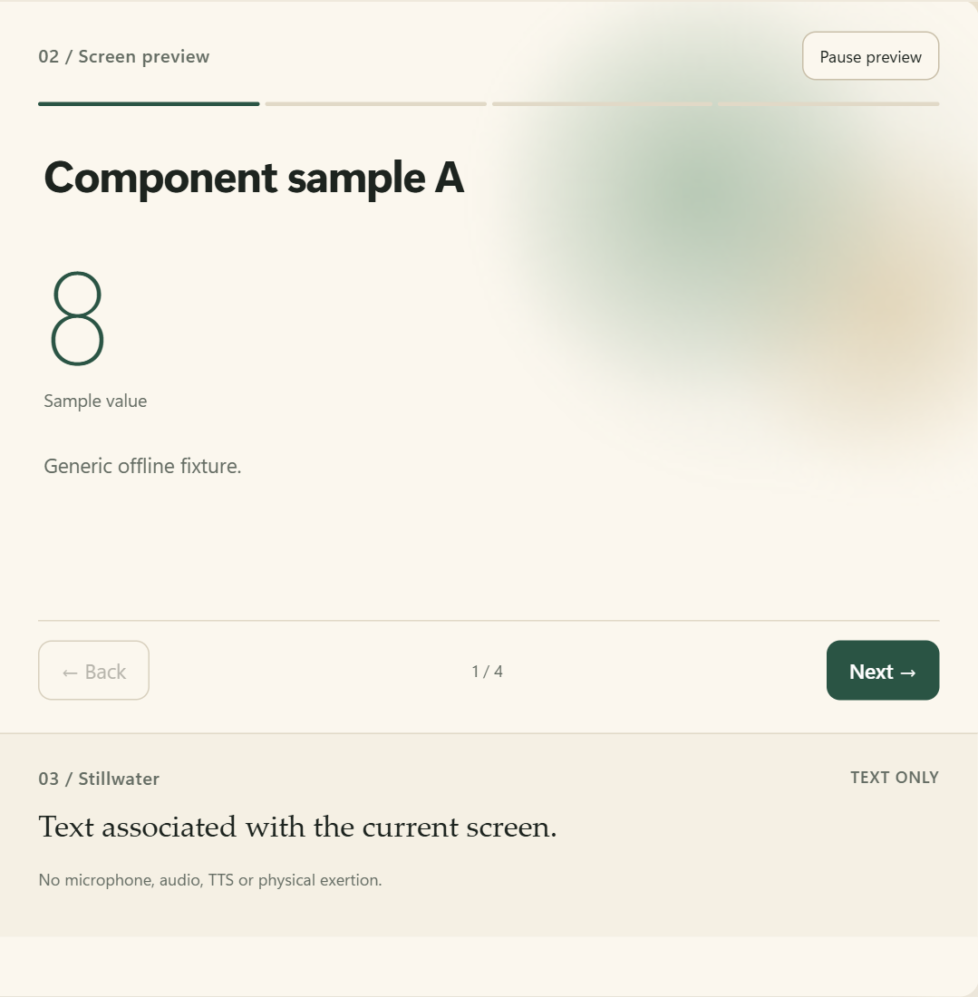
The starter’s generic component sample, the only “experience” that shipped.

Nine iterations
Phase | What I saw | What changed
1. Foundations | Durations lied; choices ignored | One data source for sessions, so durations are computed and cannot drift
2. Name entry | Name typed into a chat box; retries silently ignored | A validated name field on the screen; root-cause fix for retries
3. Personality and ending | A scorecard ending; repeated encouragement | One calm voice; a closing moment first, the timer record folded beneath
4. Presence | Timers had to be manually finished | A finished timer leads to the next movement, never auto-starting it
5. Natural language | “Say it in your own words” did nothing | A keyword intent layer (replaced by Claude plus a floor in v2)
6. Adaptation and safety | Pain did not stop anything | “Tell Stillwater” on every movement; a safety hold that pauses and locks
7. One workout stage | Flat pages of stacked blocks | A persistent stage: movement, dial timer, progress, what is next
8. Reliability | Invalid-screen errors after repeated offers | Root-cause fix, bounded context, a words-only fallback
9. Visual system | Every surface its own shade | A small colour-token system; motion only for real state changes

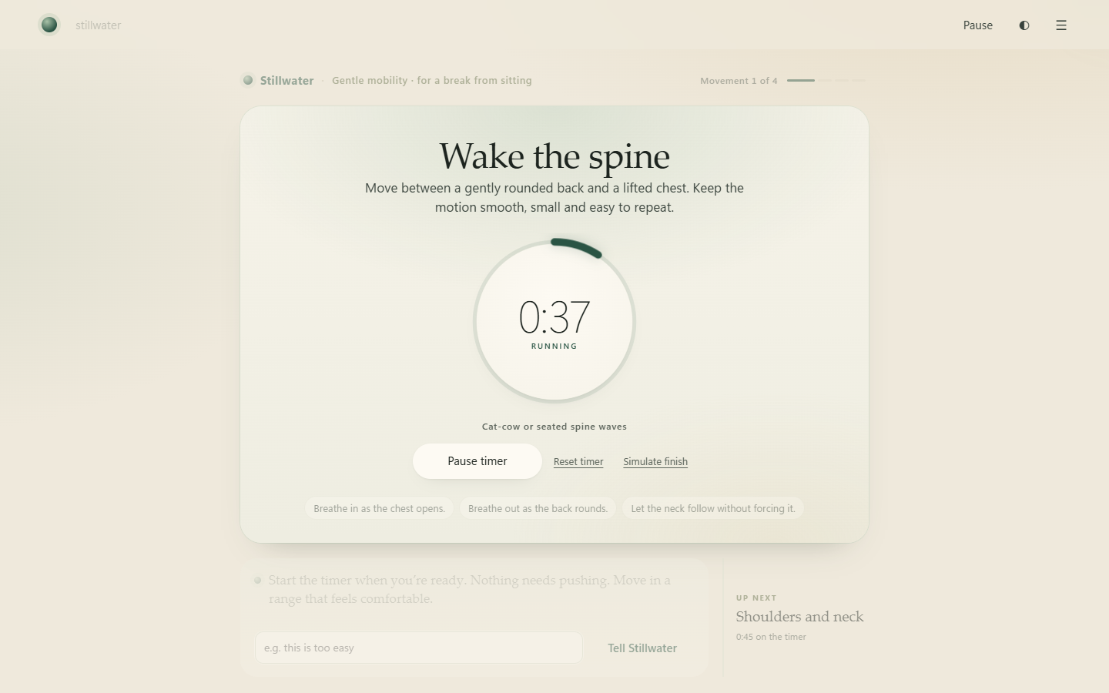
The integrated workout stage from version 1, unchanged in version 2.

7. Key decisions and trade-offs
Decision | Alternatives considered | Why this way
v2: Claude interprets; code draws | AI generates whole screens | Keeps every duration, movement and safety message tested and true, while still understanding loose language
v2: Keyword floor that AI cannot lower | Trust the model alone | Adding AI must never make a fitness product less safe
v2: Fixed safety wording | Let the model phrase safety messages | Safety copy should be reviewed once and never vary
v2: Two questions, style removed | Keep all six screens | Friction before value; tone-only personalisation was not noticed
v2: Word at the end, tied to a movement | Word at the start | Meaning and a reason to return, not trivia before the workout
v2: Plan login route as well as API | API only | Lets the AI run without paid credit; the API stays faster and preferred
Confirm meaningful changes | Fully automatic adaptation | Keeps the person in control
Safety with no substitute exercise | Offer a “safer” movement | A text-only product cannot judge what is safe after pain
Timer record folded under the ending | Lead with stats | Closure first, transparency one click away

8. Safety, honesty and trust
Situation | What Stillwater does
Pain, injury or rehab before a session (keywords or Claude) | Replaces the choices with a warning and a recommendation to seek a doctor or physiotherapist. Offers “Not today” or “Show the session choices”.
Pain or dizziness during a session, however casually said | Pauses the timer, locks navigation, and offers only “End the session” or “I’ve rested and feel okay”.
Chest pain, breathing trouble, fainting, numbness | Urgent-care guidance; no route back into exercise.
Claude and keywords disagree | The more cautious reading wins.
Claude unavailable | Keywords answer; the reply says the offline reader answered.
Figures of speech (“pain in the neck day”) | Not treated as a body concern, while real pain next to them still is.
Weight-loss or calorie goals | Supports general movement; says plainly that a few minutes is not a weight-loss plan.
Timer reaches zero | Recorded as time on a page; the ending never claims you exercised.
Typed messages with Claude on | Sent to Anthropic to be read, after explicit consent. Taps are not. Mock sends nothing.

9. Visual and interaction design
Unchanged from version 1: a warm ivory base, forest green for action, sage and olive for presence and completed states, a serif for the companion’s voice and the movement name, and motion only for real state changes (all of it off under reduced motion).
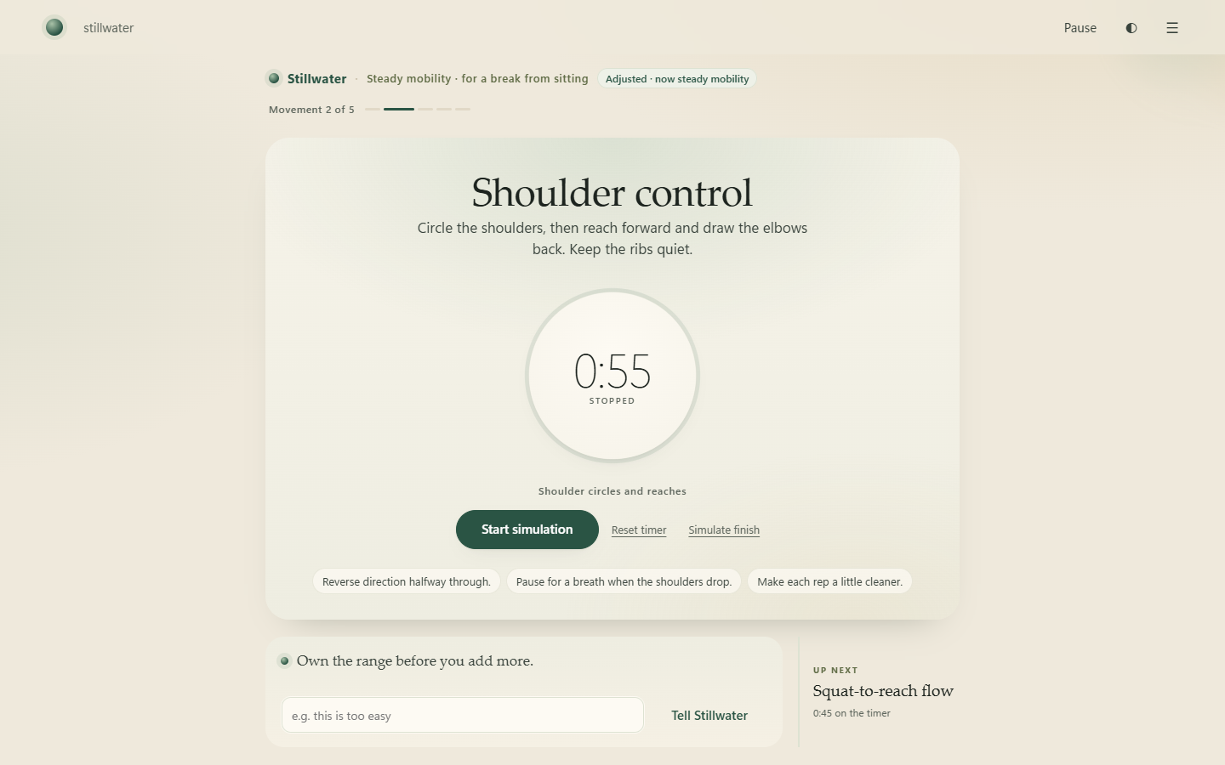
A confirmed adjustment is visible in the workout itself: “Adjusted · now steady mobility”.
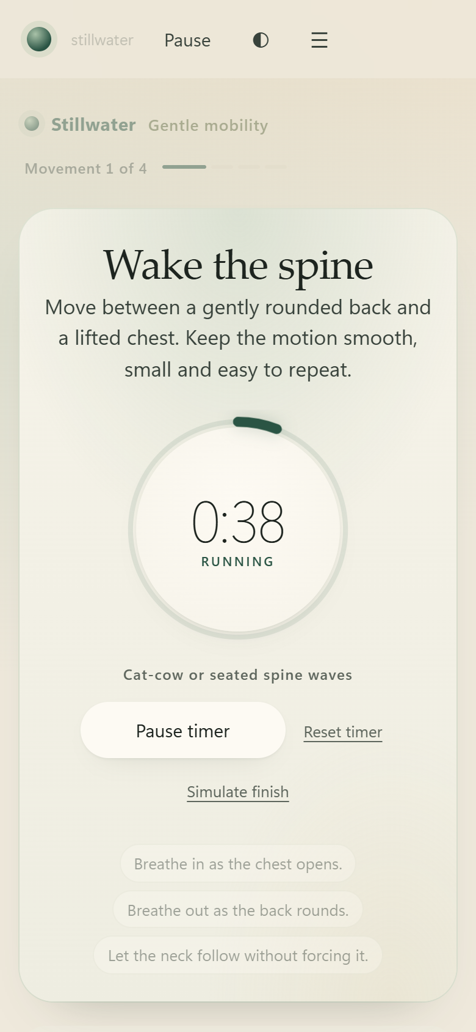
The same stage on a phone.

10. How it is built
Layer | Responsibility
Understanding (new) | guide.ts asks Claude for a fixed-format reading, checks it, merges it with the keyword floor, and falls back if needed. Its instructions are a short, principle-based document with examples.
Content and behaviour | Onboarding, sessions, the keyword layer, safety, endings and session words. Fully local.
Screens | Declarative data in a small screen language, validated and rendered by trusted local code.
Workout stage | The dial, progress, safety hold and offers, built on the starter’s timer and navigation.
Evaluation (new) | 44 realistic messages and a script that scores both approaches and records date, model and latency.
Walkthrough (new) | A script that drives the real app with Claude live, records the video and captures these screenshots.

The starter harness (parser, base components, timer ledger, navigation, server and adapters) remains its authors’ work and is credited in the source.

11. Quality and verification
Check | Coverage | Result
Typecheck and safety lint | Whole codebase | Pass
Unit and HTTP tests | 83 tests, incl. safety floor, fallback, output checks, CLI lock-down, idioms, word card | 83 pass · 4 skipped on Windows with a stated reason
Browser journeys | 28 journeys in Chrome | All pass
Live evaluation | 44 realistic messages through Claude | 44 / 44 (version 1 rules: 13 / 44)
End-to-end live run | Need, movement tip, safety hold through the running app | All correct

Bugs found by using the product, not by reading code
- Retrying the same name after a failure was silently ignored. (v1)
- Two pending offers collided and caused repeated invalid-screen errors. (v1)
- Long sessions hit a message cap and a document-size limit. (v1)
- “Pain in the neck day” raised a false alarm from the keyword floor, found by the first live evaluation. (v2)
- The session word disappeared after switching from gentle to steady, found while recording the walkthrough. (v2)
Each was reproduced, fixed at its root, and protected by a test.

12. Results
Measure | Version 1 | Version 2
Questions before choosing a session | 6 screens | 2
Realistic messages understood | 13 / 44 | 44 / 44
Body concerns missed | 10 of 16 | 0 of 16
False alarms | 1 | 0
Runtime modes verified | Mock | Mock + Claude live
Time per typed message | Instant (scripted) | About 7 s with Claude; taps stay instant

13. What I would do next
- Held-out evaluation: 30+ messages written by other people, scored before touching Claude’s instructions.
- Usability sessions with five to eight people: time to first movement, whether tips felt useful, “would you come back tomorrow?”.
- Physiotherapist review of movement cues and safety wording.
- Speed: compare the API route and a faster model for the reading step against the same evaluation.
- Privacy decision: whether typed text should ever be kept to improve the product, and with what consent.

14. Reflection
Deliver the core ask first. Version 1 was careful, honest and polished, and it still missed, because the polish went everywhere except the thing being assessed. Version 2 started by proving the AI worked on day one, then built around it.
AI and trust are not opposites. The most useful design decision was deciding what the model is *not* allowed to do. Letting Claude understand while trusted code draws made the product both smarter and safer.
Measure, then fix what the measurement shows. The evaluation’s two misses and the walkthrough’s missing word were the most valuable findings of version 2. Neither would have shown up in a demo I had rehearsed.
Restraint is still a design tool. Cutting four screens did more for the experience than anything I added.

Appendix: run it locally
Requires Node.js 22.18 or later. In the project folder run “npm ci --ignore-scripts” and then “npm start”, and open http://127.0.0.1:5102. It starts in Mock with no keys. To use Claude, set ALLOW_CLAUDE_PLAN=true (Claude Pro/Max login) or an API key in .env, restart, then choose Menu → Developer → Claude (guided) and agree to usage.
Try: Start with Stillwater → enter a name → type “been hunched over a laptop all day” → accept → start the timer → type “my wrists are tired”, then “ooh that pinched”. The walkthrough video in the project folder shows the same journey.
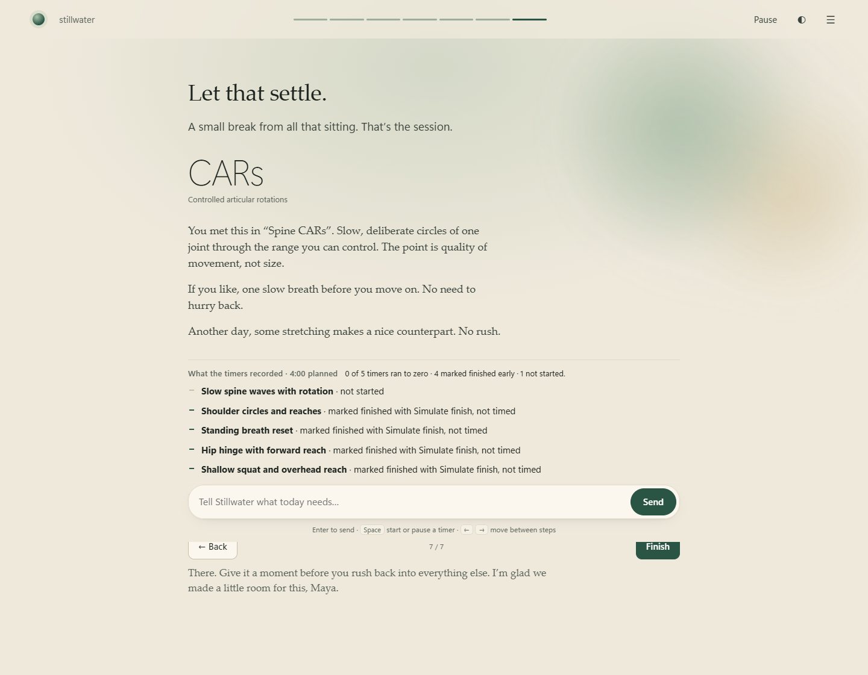
The full workspace at the close of a session, with the honest timer record.

